The Demographic Situation of Kirkuk
And Iraqi Constitution

Erşat Hürmüzlü

The demographic structure of the Turkmens in Iraq is unlike those of the Arabs, Kurds and other minorities. The tribal system, with its advantages and disadvantages, is rooted among Arabs and Kurds, rendering blind loyalty to the tribe, granting tribal chiefs absolute powers, which led to the birth of the feudal system removing debate from decision-making and creating a lack of equal opportunities.

The Turkmens, however, are more family oriented, having intimate feelings for descendants from a grand grandfather who held the same family name. The family system, however, did not prevent any member from getting his share of respect, honor and fame due to a religious, academic or professional status.

This very difference, which was neglected by many researchers, may be a reason for the diminished role of the Turkmen in the structure of the Iraqi society.

However, there are other reasons behind this issue, mainly the attempts to change the reality of the Turkmen existence in Iraq in order to annex Kirkuk into a specific region.

What we can see from either Kurdish political parties or from the publications of the Saddam Hussein regime in Iraq is that they were in agreement in only one subject, which is the denial of the actual size of this component of Iraq.

Let me give you one example, The Patriot Union of Kurdistan web site has published very recently an article adopted from their own newspaper “Kurdistani Nwe” saying:

We have found a document in the archives of the Foreign Affairs of Britain which depicted the makeup of the inhabitants of Kirkuk in the year 1919. At that time and according to this document the inhabitants of Kirkuk were 91 229, 75 thousand of which were Kurds.

In fact, the official documents of the National Archives in London, in which I have personally researched and studied, show clearly that the British delegation to Lausanne conference in early twentieth of the last century headed by Lord Curzon, had submitted their own figures which states clearly, and although the figures were questionable, that the Kurds were less than half in Kirkuk.

The cause of this disinformation was because an “error” was made in one of the Kurdish writers’ book, published in Arabic, saying that the division of the ethnicities in Kirkuk was as follows: 10,000 Arabs, 35,000 Turkmen, 75,000 Kurds, 600 Kildaniens and 1400 Jews. The total had been published as 92000.
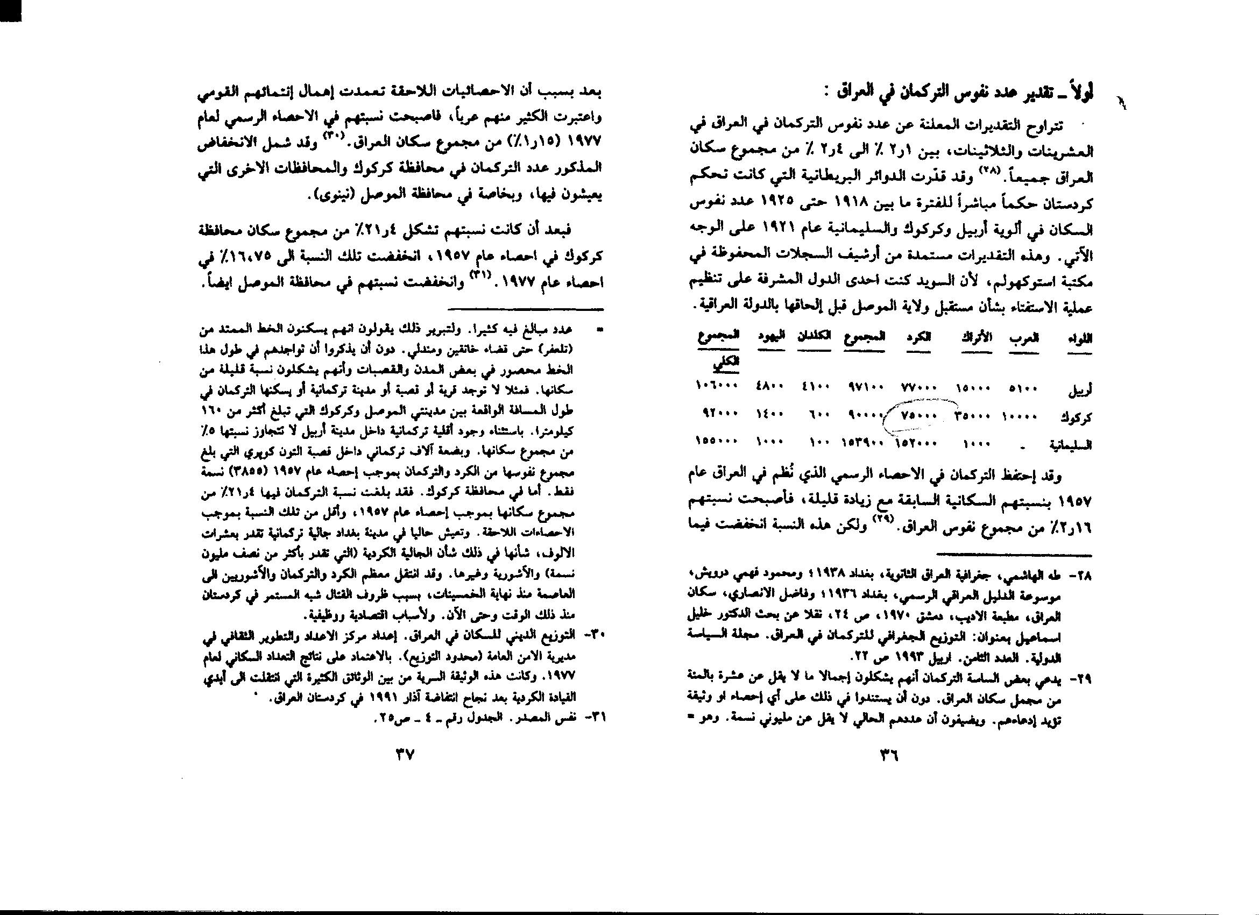

Simple arithmetic will clearly yield the total to be 122,000, and not 92,000. The reason was that in actual figures the number of the Kurds was 45,000 and not 75,000. That means that even with these false figures the Kurds were constituted less than half of the whole governorate and not the central city.

Division | Arabs | Kurds | Turks | Christians | Jews | Total
Mosul  Arbil  Kirkuk  Suleimaniyah | 170.663  5.100  10.000  --------- | 179.820*  77.000  45.000  152.900 | 14.895  15.000  35.000  1.000 | 57.425  4.100  600  100 | 9.665  4.800  1.400  1.000 | 432.468  106.000  92.000  155.000
Total | 185.763 | 454.720 | 65.895 | 62.225 | 16.865 | 785.468

Why have we considered the figures submitted by the British delegation and Lord Curzon as false?

In his memorandum to the Head of the Turkish Delegation, Ismet Inonu, during the open sessions of the conference, Curzon claimed that the Turkmen population within Mosul Region was 66,000. He claimed also that these figures belong to the researches done by the British officers visited each and every settlement in the region, sometimes even on horseback or by any means necessary to count the people properly in 1919.

However we have discovered the same figures in the report of Wikie Young, one of the staff of British Consulate in Mosul, who clearly states his own estimates by saying that the inhabitants of Kirkuk at that time was 40,000, save 3000 non Muslims, the rest (i.e. 37,000) were all Turkmen.

He adds 1,500 Turkmen living in Tuzhurmato, 10,000 Turkmen in Telafer and quarter of Erbil inhabitants who were as much as 60000(i.e. 15000) were Turkmen. He also mentions that the all Bayat tribe people were Turkmen, say 2500 at that time. The total is 66000. (The Report of Mr. Young dated 5th.April 1910, The National Archives, File No: FO 371/1008.

If we look at the figures presented by the Turkish delegation at that time, we see that the Turks were not claiming that they have collected these figures by officers riding on horsebacks, but from the official records of the state which used to be registered by each part of the Ottoman Empire. These figures were registered before the war when there was no reason to exaggerate the numbers at all. The figures mentioned in this statement show the Turkmen at 146,000. The same statements show the Kurds at that time at 263,000. If we consider the estimations made in the Oil for Food programme of the United Nations and the percentage adopted in the new Iraqi budgets we see that the Kurds are at 17% of the Iraqi population. Now, 17% of 25 million should be slightly more than 4 million. If we consider in the absence of a real census in Iraq that the Turkmen are above 2 million, we see that really the figures of the Turkish delegation were accurate.

The British authorities never denied that the majority of Kirkuk is Turkmen. This was even stated in 1952 in a report from the British Ambassador in Iraq Mr. J.M. Trulbil, addressed to the British Minister of Foreign Affairs, Anthony Eden, about the former’s visit to Kirkuk, Suleimaniya and Erbil during the period from 10-14 May 1952, he stated:
“The issue of minorities in Iraq is based on the relationship between the Arabs and non-Arabs, and this relation is evident now than ever before. The coexistence and harmony is clearly demonstrated in Kirkuk, for Turkmens constitute the majority of the population in that region and they live with Arabs and Kurds side by side”. (The British National Archives, London, File No. F.O/173/98738, report of the Oriental Dept. E/1018/2).

We know that the accurate figures of the Turkmen announced by the Iraqi republic after the military coup in 1958 show the real stand as 567 000( as stated in the report of the Washington Institute for Near East Policy, Policy watch No. 735, March27, 2003). If we adopt and again in the absence of accurate census, the growth rates of Iraq in general which based on Iraqi population growth rates being approximately 3.2% throughout the 50s, 60s and 70s; 2.6% in the 80s; 2.4% from 1990-92, and 2.3% in 1993 as per the figures quoted in the 1993 Unified Economic Report published by the Arab Fund for Economics and Social Development; the Arab Monetary Fund, and the Arab Organization of Petroleum Exporting Countries, then we can calculate this figures nowadays as more than 2 millions. This fact is in conformity with the above said report stating the percentage of the Turkmen population in Iraq as 9%. In the present we are talking about 25 million living in Iraq, 9% of which is 2,250,000.

Especially in Kirkuk, the situation was always in this regard, until recent attempts began to severely change the ethnic stance of Kirkuk and its surrounding areas. Even the Kurds have accepted this reality during the negotiations between the Iraqi Kurds and the government. We see in David McDowell’s book, A Modern History of Kurds, İ.B. Tauris, New York 1996, the following statement:

“Mulla Mustafa (Barzani) accused the government of resettling Arabs in the contrasted areas Kirkuk, Khaniqin and Sinjar and told government that he would not accept the census results if the indicate is an Arab majority. He also dismissed the offer of 1965 census, which he said forged. When the government proposed to apply 1957 census to Kirkuk, Mulla Mustafa refused it, since this was bound to show that the Turkmen’s, although outnumbered in the governorate as a whole was still predominant in Kirkuk town.”

Documents:

I have presented tens of the documents including the official maps and reports of the British government, researchers and authors, which none of them are Turks or Turkmen, stating the ethnic reality of Kirkuk as Turkmen.

In dispute, the majority of the Kurdish authors persistently deny the extent of the historical Turkmen presence in Kirkuk; referring to Shemseddin Sami’s Kamus al Alam (Dictionary of the Individuals) as a factual and reputable authority. It is, in fact, an Ottoman encyclopedia of history and geography which makes the highly-dubious claim that three quarters of Kirkuk’s population are Kurds, the remainder being made up of Turkmen, Arabs and other ethnic groups.

Almost all of these authors refer to what they regard as the most authoritative and reliable sources in this regard. They always mention Shamseddin Sami’s work already referred to, as an author they describe as a Turkish historian and traveler holding no particular allegiance to the Kurds, who had visited Kirkuk and written, according to them, an accurate account of the area and its inhabitants.

As a matter of fact, Shamseddin Sami was not Turkish. He was born in Albania in 1266 (AH) (1849 G) where he received his early education in the Greek school at Yanya, and learned Turkish, Persian and Arabic from a private tutor. He later moved to Istanbul where he launched a newspaper ‘Sabah.’ He then turned to writing fiction, among his early stories being ‘The Love Story of Talat and Fitnat,’ which openly questioned Ottoman marriage traditions and ethics. He followed this with ‘The Revolution of Kawa, the Blacksmith,’ which depicted the hero’s struggle against the dictator, Dhahhak. The reaction of the Turkish authorities was to exile him to Tripoli, but he eventually returned to Istanbul where he devoted his time to writing language texts and works of non-fiction.

Ironically, Sami was not a traveler at all, never having once visited Kirkuk or Baghdad despite writing knowledgeably and authoritatively about both cities. The reference to his major work, referred to above, in the Islamic Encyclopedia clearly states that he compiled it from information he obtained in Bouillet’s Dictionaries et de Geographie Universal d’Histoire, various Arab and Persian sources and the largely inaccurate reports and records of government officials. His credibility is also seriously undermined by his references to Baghdad as a ‘Turkish’ city where, he claimed, mainly Turkish was spoken, with Arabic being relegated to second place.

Last statement

In a debate, one of the colleagues was mentioning that the Turkmen always exaggerate their numbers in Iraq and that they do not exceed, as he thinks 7-8 hundred thousands.

In my answer I have mentioned that the natural rights of any individual in any community, are totally independent of the latter’s size or strength, in accordance with the principles laid down by the International Declaration of Human rights (and, in addition, upheld by the terms of the aforementioned Iraqi constitution, the temporary constitution which succeeded it and finally the new permanent constitution).

Even if the testimony of Kurdish writers or others like the said colleague is accepted as valid (though they have generally tended to grossly underestimate the numbers of Turkmen in the Kirkuk region) the fact has to be recognized that the Turkmen population actually exceeds that of several entire independent, internationally recognized nations, for instance in The Arabian gulf, Europe and Africa.

I have reminded this friend who resides in Geneva, Switzerland to have a look at the Swiss currency, the Swiss Frank. He would see four native languages on it, including Romansh who at time did not exceed 30,000 people, but had 5 members in Parliament in Bern, not because they were a minority, rather because they had the capability and qualities to hold the seat in the parliament.

we wish to affirm our views as Iraqi Turkmens toward the ethnicities issue in Iraq adopted from the Turkmen Charter, in which we believe: It is the firm belief of the Turkmen that the ideal solution for the ethnic problems in Iraq will come to fruition only when the process builds on a solid foundation that embraces all the ethnicities and groups and considers them all as first class citizens and partners in a single nation. The selection of a free and sovereign united government system should be according to the resolve and free will of the Iraqis.

There should be no attempt to push aside any ethnic group or sect of people and withstand from exaggerating the role of one group over another because of certain exceptional state of affairs. Any solution that resorts to and implements the principles of the International Declarations of the Human Rights will become a transitional solution dictated by the current situation and should not represent full heartedly the blessing of the Iraqi people.

The Turkmen citizens affirm their respect for a comprehensive decision by the Iraqis that should take into consideration all the Iraqi ethnic groups who should exercise equal rights in shouldering similar duties in the regions that they inhabit and, that this should be conditional on the credible and just demographic census under the supervision of the United Nations.

The Iraqi Turkmen predict a united, democratic, pluralistic and parliamentary Iraq, in which the government will be chosen by a free and credible election according to international standards, and will not be subjected to narrow-minded ethnic determinations in the distribution of authority or governmental positions. In the public service, the Turkmen believe that efficiency, qualifications, experience, and clear vision should become the standard.

Some people talk sometimes about the rosy futures and urge the people not to live in the past but to look forward. May I suggest here that we should specifically in this subject go backward to the past. To adopt and implement the norms accepted in 1948 International declaration of Human Rights. Moreover to go back to the Iraqi constitution of 1925, which I believe it was more moderate and acceptable than all constitution followed, including the so called permanent constitution. Let me share with you what I have counted in 2005 constitution. There are references in this to Sunni, Shea, Arab, Arabic, Kurds, Kurdistan, Turkmen, Assyrians, Kildaniens, Yazidies, Sabia, Armenians, Muslims and Christians 25 times. While such a reference in 1925 constitution is only one and it is related to the official language of Iraq provided that the other languages are also respected.

The Turkmen citizens completely realize the current situation of the unfair political maneuvers that favors the interest of one group over the others, or those that attempt to smear other ethnicities or nationals as conspirators. They vow not to fall into this trap and, they call on other ethnic groups to adopt a similar stance towards the Turkmen citizens of Iraq.

