Abduction Turkmen News Reader by Kurdish forces in Erbil

By Mofak Salman

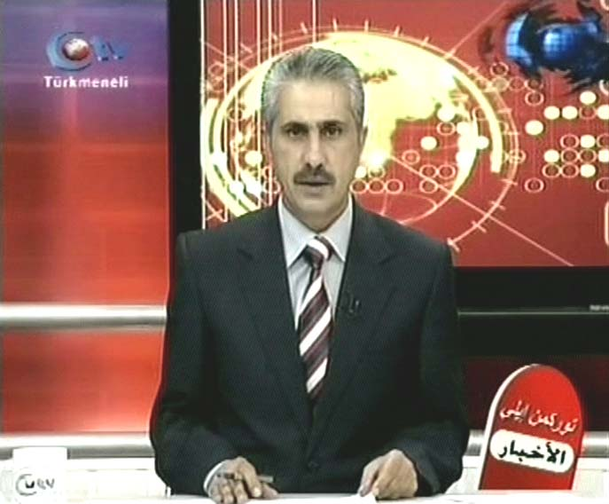
Turkmeneli TV news reader Mr. Timor Beyatli

Mr. Timor Beyatli is a Turkmen [1] citizen who is employed by the Turkmeneli [2] TV as a news reader at the Arabic section that broadcast from Kerkuk in Iraq. On the 5th of November 2008, Mr Timor Beyatli was on his way to Turkey to participate in conference about Media and Journalism in Istanbul, Turkey.

On the same day he left the city of Kirkuk to head towards the city of Erbil to get his flight from Erbil airport and an approximately 6.45pm before boarding his airplane he had made his a final call to his family in Turkey informing his family that he would be on his way to Istanbul airport and he would contact them upon his arrival in Istanbul, but unfortunately when the plane was landed in Istanbul he was not among the arrival of passengers.

In fact he was abducted at the airport in Irbil airport by a Kurdish security force known as the Asayish [3] that belongs to the Kurdish leader of the KDP party Massuad Barzani prior the flight which was at 8.15pm. Mr. Tamur Beyatli was transferred from the Erbil airport to a prison in the city of Erbil for further investigation.

Also on the 25th November, 2007 Mr. Hassan Turan, a member of the governing council of Kirkuk, was arrested by the Kurdish Asayish at Erbil airport in northern Iraq following his return from participation in the international conference that was held in Istanbul in Turkey under the name of Kudus and International Conjunction .

In addition to that, on Saturday 27th October, 2007 Qasim Sari Kahya, the Turkmen writer, journalist and Secretary Editor for the Fraternity Club of Kardeslik in Baghdad, was abducted along with another three Turkmen citizens near the Kirkuk General Hospital by a Kurdish security force known as Asayish. Although, several hours later, three of the detainees were released, Mr. Qasim was kept for further interrogation.

Moreover, Mr. Lokman Nejam Ahmed was born in 1st July 1968 in the district of Telkeef that is linked to the city of city of Mosul. He was arrested on the 8th of July 2007 on the Iraqi/Turkish border Ibrahim Alkhalil by the Kurdish secret police that are known as Asayish while he was travelling from the city of Mosul to Turkey with a group of a Turkmen from the city of Erbil.

Document shows the kidnapping and arresting the Turkmen in North of Iraq. Parts of confidential State Department documents circulated to the White House, the Pentagon and the U.S Embassy in Baghdad about the abduction of the minority Arabs and Turkmen in Kirkuk and their transfer to the Kurdish north. [Doc.1]
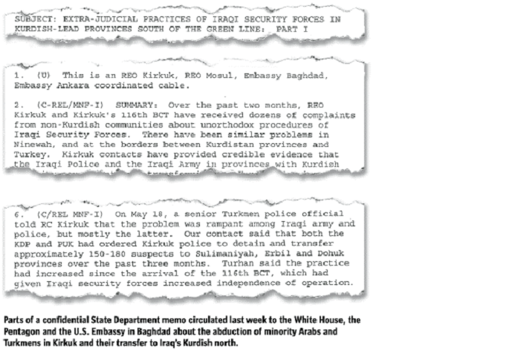

Doc. (1)
Because of the public, political, and journalistic outrage and due to the public appeal on TV and radio and Media, Mr. Tamur Beyatli was released on 7th November 2008. He was released without from the detention without formal charges and his case has not been submitted to the court.
Thus, the Turkmens plight to all the human right organisations, government officials, intellectuals, and Iraqi and Turkish government for immediate intervention to put pressure on the Kurdish police whom are terrorising the Turkmen people in Turkmeneli.
Turkmen of Iraq also call upon the Iraqi Journalists Union and all Iraqi and international organizations defending the rights of journalists and freedom of the press to move immediately to the authorities of the Iraqi government at the highest levels for the protection of the Turkmen, Arabs and Assyrian from the Kurdish oppression that are carried by Kurdish parties in North of Iraq.

Mofak Salman
Turkmeneli Party Representative for Both Ireland and United Kingdom
msalman@eircom.net

[1] Turkmen: The Iraqi Turkmen live in an area that they call “Turkmenia” in Latin or Turkmeneli” which means, “Land of the Turkmen. It was referred to as “Turcomania” by the British geographer William Guthrie in 1785. The Turkmen are a Turkic group that has a unique heritage and culture as well as linguistic, historical and cultural links with the surrounding Turkic groups such as those in Turkey and Azerbaijan. Their spoken language is closer to Azeri but their official written language is like the Turkish spoken in present-day Turkey. Their real population has always being suppressed by the authorities in Iraq for political reasons and estimated at 2%, whereas in reality their numbers are more realistically between 2.5 to 3 million, i .e. 12% of the Iraqi population.

[2] Turkmeneli is a diagonal strip of land stretching from the Syrian and Turkish border areas from
around Telafer in the north of Iraq, reaching down to the town of Mendeli on the Iranian border in
Central Iraq. The Turkmen of Iraq settled in Turkmeneli in three successive and constant migrations
from Central Asia, this increased their numbers and enabled them to establish six states in Iraq.
[3] Asayish is an unrecognized and illegitimate force that is utilized by both Kurdish parties to terrorize innocent civilian people. They are used to kidnap and kill people who defy the Kurdish aspiration for establishing a Kurdish state.

